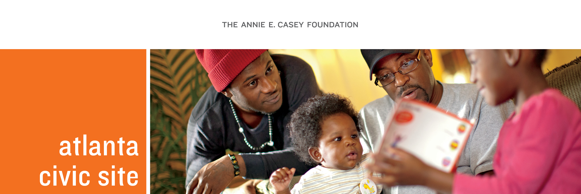
2016 Community Investment Fund Application

The Community Investment Fund awards grants to resident-led projects in Adair Park, Mechanicsville, Peoplestown, Pittsburgh, Summerhill and Capitol Gateway that can be completed by December 2016. Requests should range from $500 to $5,000 (see grant announcement for further instructions). Please complete all application sections. Applicants may attach additional pages, if necessary.

Section I: Applicant Profile

Organization/Group Name:
Project Title:
Title: | Primary Contact:
Phone: |  | Email:
Mailing Address:
City: | Zip:
Describe whether live or work in Neighborhood Planning Unit V (NPU-V):
Title: | Secondary Contact:
Phone: | Email:
Describe whether live or work in NPU-V:
Neighborhood(s):
Date Formed:
Website:

Please provide a brief narrative describing your group. How long have you worked together and what are your group’s goals and mission?

Section II: Group Contact and Financial Information

Please provide contact information for each additional member of the project team, beyond those listed above. The team should consist of at least two unrelated applicants. Team members must be residents of, or work in, the community that the project intends to serve. At least one member must be older than 18.

Name and Role/Activity With This Request | Complete Address | Email/Phone

Your group must have an Internal Revenue Service nonprofit tax exemption letter or an agreement with a third-party nonprofit tax exempt organization to receive funds on your behalf. PLEASE NOTE: An agreement with a third-party organization should be established prior to submitting an application and a letter of agreement provided. If you are using a fiscal agent, the agreement letter with your fiscal agent should specify the roles and responsibilities of each organization/group. If you are using a fiscal agent, we prefer that agent be located within NPU-V.

Tax Exemption Letter Attached Third-Party Organization/Fiscal Agent Agreement Letter Attached

Third Party/Fiscal Agent Contact Information:

Individuals with access to project funds:
1.
2.
Fiscal Agent Agreement date:

Does your group have any experience with managing funds (together or separately) or working with the third-party partner indicated above?

Yes No

Please discuss your response:

Section III: Request

- Which focus area does this project address (check all that apply):

Neighborhood Transformation Education Achievement Family Economic Success

- Describe your project. Indicate whether this project is part of a larger strategy, for example, did it come out of a community planning process? If it involves physical improvements, provide the address and submit photos (please insert photos below or attach them to your application).

- Please list the scope of work for this project. This should describe the tasks that you will need to complete to accomplish the project goals and when you anticipate completing each activity.

Activity | Date
Example: Distribute fliers for community cleanup | July 2016

- If your project involves serving children, please describe steps you are taking to ensure the safety of the children and obtain permission from their parents.

- How will you raise awareness of the project and ensure that neighborhood residents are involved?

- Is this a new project or part of an ongoing initiative? If ongoing, please describe your accomplishments thus far.

- What are your goals for the project? What are the performance measures (numerical measure)? How will you know that you have been successful?

GOAL | Performance Measure
Example: Pick up trash from an abandoned lot | XX bags collected

- Once you have accomplished these goals, what difference do you think it will make for the community? Provide a narrative describing the anticipated results for the community.

- How will your group sustain the project after the grant is complete?

- Have you received a CIF grant previously? If so, what were your major accomplishments?

- Please feel free to attach a letter of support that you think might be helpful to your application (not required).

Section IV: Budget

Annual Operating Budget: (OK to answer ‘0’)

Amount Requested:

Please complete the budget table for the total cost of the request. Examples of allowable grant expenses include meeting expenses, food, equipment/space rental, professional services, fiscal agent fee (no more than 10 percent of ask), copying, marketing/advertising, materials or other direct expenses. Stipends, salaries or other compensation for time of project team members are not allowable expenses. Please note that the amount requested column must equal the amount requested above.

Item | Total Cost | Amount Requested | Narrative Description  (Purpose, timing, in-kind, etc.)
TOTAL

Has this project received funding from other sources? If so, please indicate source and amount.

SOURCE | AMOUNT
TOTAL

Section V: Acknowledgment

Two signatures are required.

To the best of my knowledge, the information given in this application is accurate and complete. By authorizing this application, we attest to the accuracy of this data and agree to the responsibility of managing this project if the grant is awarded.

Signature: | Title: | Date:
Signature: | Title: | Date

Applications are due by 5 p.m. Friday, March 18, 2016. Please send completed applications to Kristina Sales at ksales@aecf.org (email preferred) or to:

The Annie E. Casey Foundation, Atlanta Civic Site
477 Windsor Street, SW
Suite 304
Atlanta, Georgia 30312
ATTENTION: Community Investment Fund Application

For questions or additional information, please call 678.686.0145. Thank you for your interest!

The Annie E. Casey Foundation
Atlanta Civic Site
477 Windsor Street SW
Suite 304
Atlanta, GA 30312
678.686.0145 P
www.aecf.org/atlanta

